Weekly exercise 4:
1)
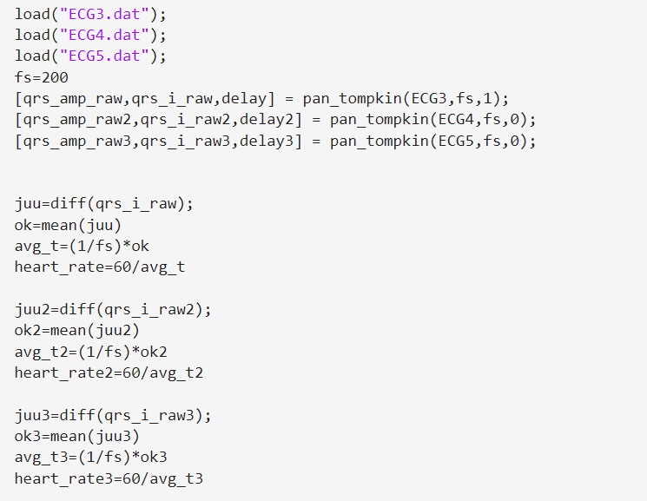
I found from internet Pan-Tompkin function, which gives as an out R-peaks amplitudes, amplitude´s indexes and delay. Then I took derivative of indexes which gives as output distance between peaks. In other word, how many indexes are between peaks. Then I took average of them. After that changed it to time by factoring it to time between samples. Then I get average heart rate calculating how many peak intervalls 1 minute includes.
Heart rates:
ECG3: 73.7bpm
ECG4: 95.1bpm
ECG5:134.7bpm
2)
a) Sharp spikes are usually related to epilepsy. One useful tool for detection of spike transients in EEG signal is template matching. First, we must extract an epoch of spike transient and use it for a template matching. Then we must do correlation between the template and EEG-signal and detect the similar events.
The result of template matching is calculated using the normalized coefficient:
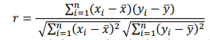
We get strong and clear peaks obtained at each occurrence of the spike transient. The peaks in the result occur at same instants of time as the corresponding spike transients.

b) Derivative based methods are often used in real time analysis or for large datasets for QRS detection. One of the most popular single-lead first derivative based QRS detection methods is Hamilton and Tompkins, whose first version Pan and Tompkins we describe since they use the same preprocessing scheme but different decision stage.
Derivative based methods for QRS:
- Take at least two cycles of filtered ECG.
- QRS has the larges slope in a cardiac cycle, so the derivative is big and the slow P and T waves are suppressed.
- Calculate the first and second order derivatives to get the slope and change in the slope and combine these two.
- The result needs to be compared to threshold values. If at least 6 of 8 samples pass the threshold test, the segment will be part of a QRS
- Then take eight-point moving average.
- Algorithm produces peaks at the times of QRS complexes but there is still delay introduced by the filters so there is difference in result peaks and QRS complex locations.
Maybe could have been told more about Pan-Tompkins. My answer was quite a common level answer.
3)
Detection on P waves is difficult because typically P wave has a low amplitude, has an ill-defined and variable shape and could be placed in a background of noise of varying size and origin.
Detecting P waves:
- Detect QRS for example with Pan-Tompkins algorithm
- Delete and replace QRS complex with baseline
- Bandpass filtering with cutoff frequencies 3Hz and 11Hz
- The search interval for P wave is gotten with equation $QT_{max}=\frac{2}{9}RR+250ms$. where RR is interval between R-peaks.
- The signal is retrified and thresholded at 50% and 75% of the maximum value. By dividing peaks to 3 levels, we get a simplified model of P wave
- Then we can do the cross-correlation between our simplified model and reference wave
- As a result the peak of cross-correlation corresponds to the P wave location in the original ECG

Result: No actual mistakes. 1.9/2

